
DHARMSINH DESAI UNIVERSITY, NADIAD
FACULTY OF MANAGEMENT AND INFORMATION SCIENCE
B.C.A. SEMESTER VI
SUBJECT: (25BCA601)SYSTEM DEVELOPMENT PROJECT
Student Name | Himanshu D Ladha
Roll No | BCA045
Student ID | 23BCUOS055

Project Definition: RestoFlow – A full-stack Restaurant Management Platform.

Company Timing: 11:00 AM to 6:00 PM

Week | Date | Day | Name of the Topic | Signature
Tenth Week | 02-02-2026 | Monday | Solve the Payment issue
Tenth Week | 03-02-2026 | Tuesday | Added day by day analytics
Tenth Week | 04-01-2026 | Wednesday | Create the Use Case Diagram
Tenth Week | 05-01-2026 | Thursday | DFD diagram creation
Tenth Week | 06-01-2026 | Friday | DFD diagram creation

External Guide Name: Somil Sir Internal Guide Name: Prof. Rupal Patel
Signature Signature

02-02-2026
- Solve the issue regarding the Payment while using the stripe payment.
- Have the limit of Rs. 50 in the stripe that’s why the problem is there.
03-02-2026
- Added the Day Analytics of the Revenue get on that particular day.
- Same way by selecting the day, which item are sold more that also can be seen.
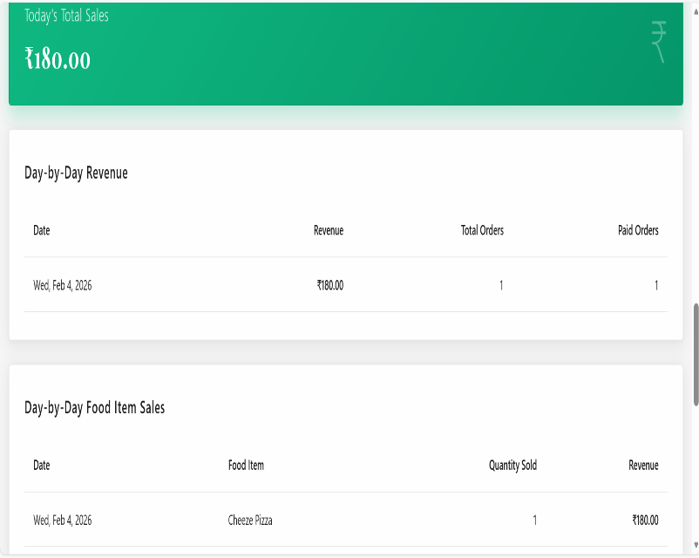
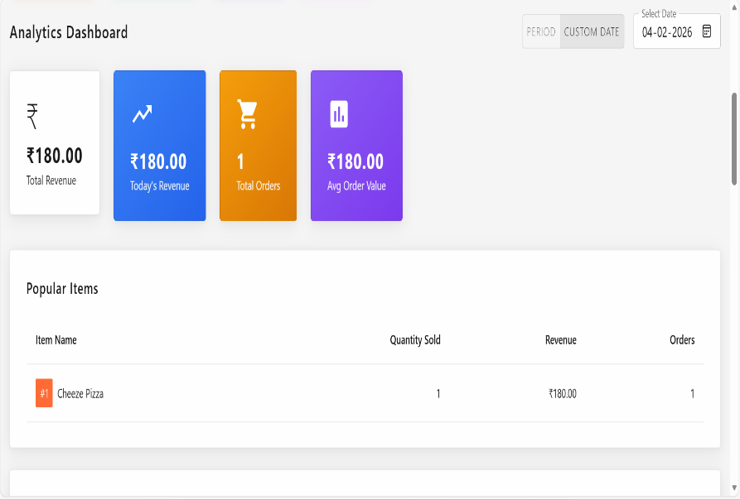
- Day wise and proper analytics has been added in the system.
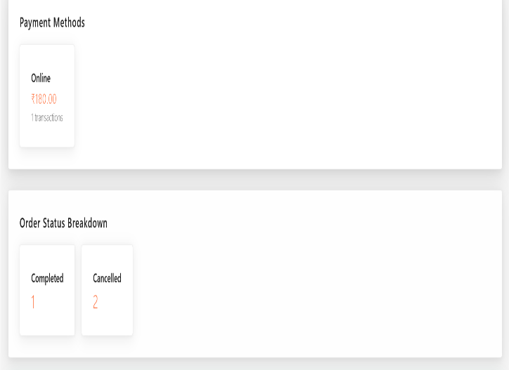
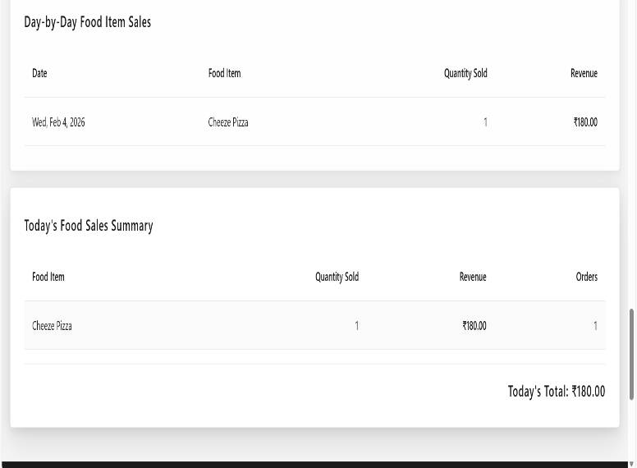

04-02-2026
- Use Case Diagram
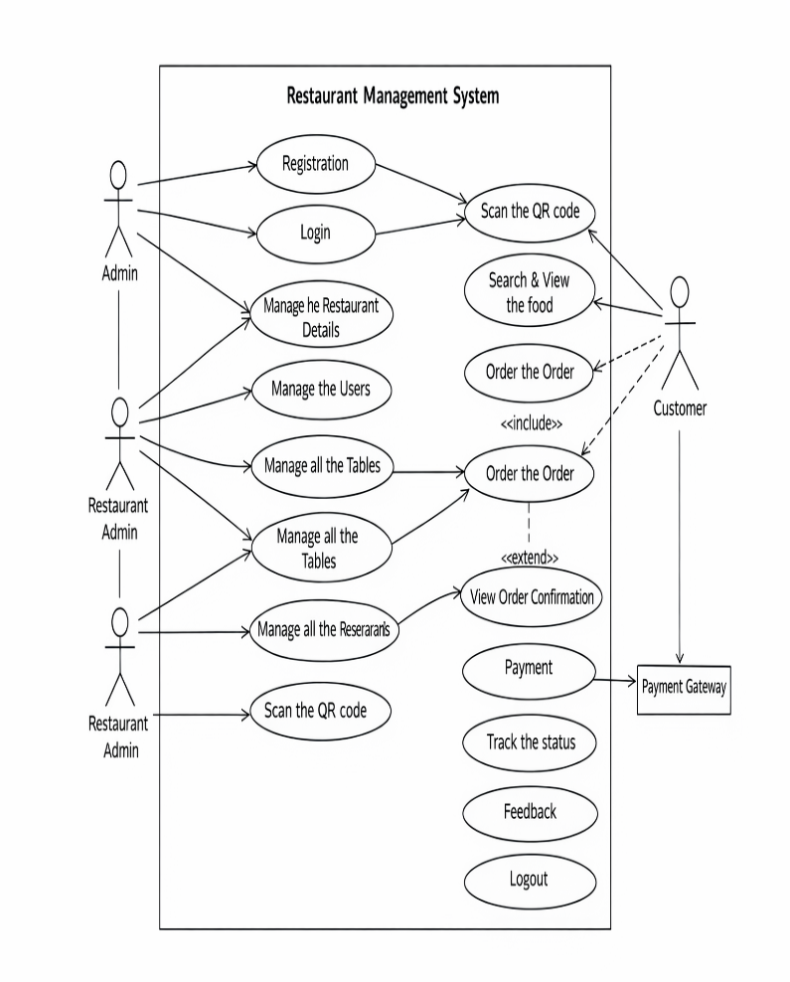
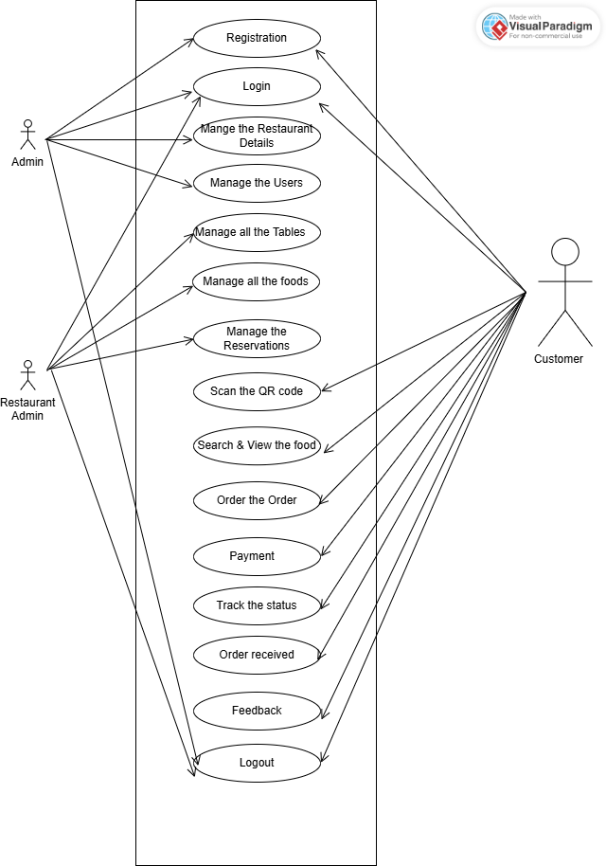
05-02-2026
- Level 0 DFD
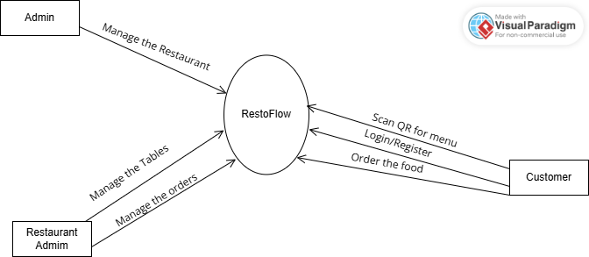
- Level 1 DFD
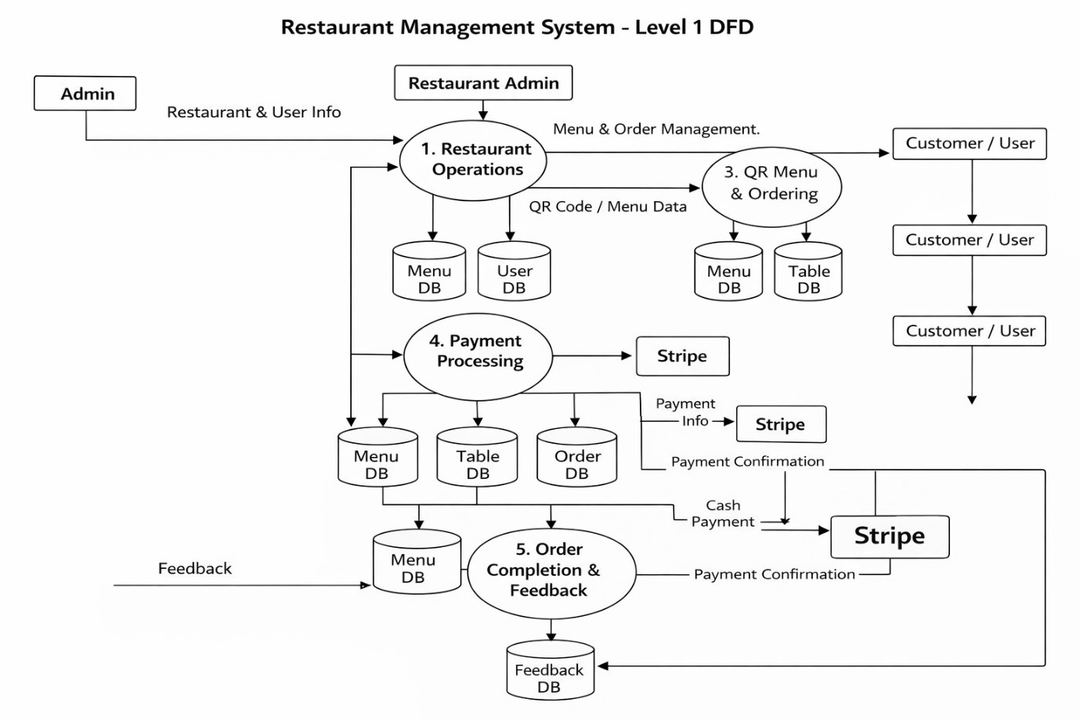
- Level 2 DFD
  - 1. Food Management
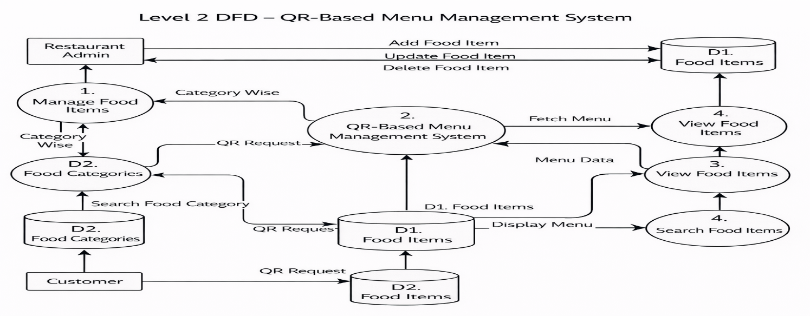
- 2. User Management
User
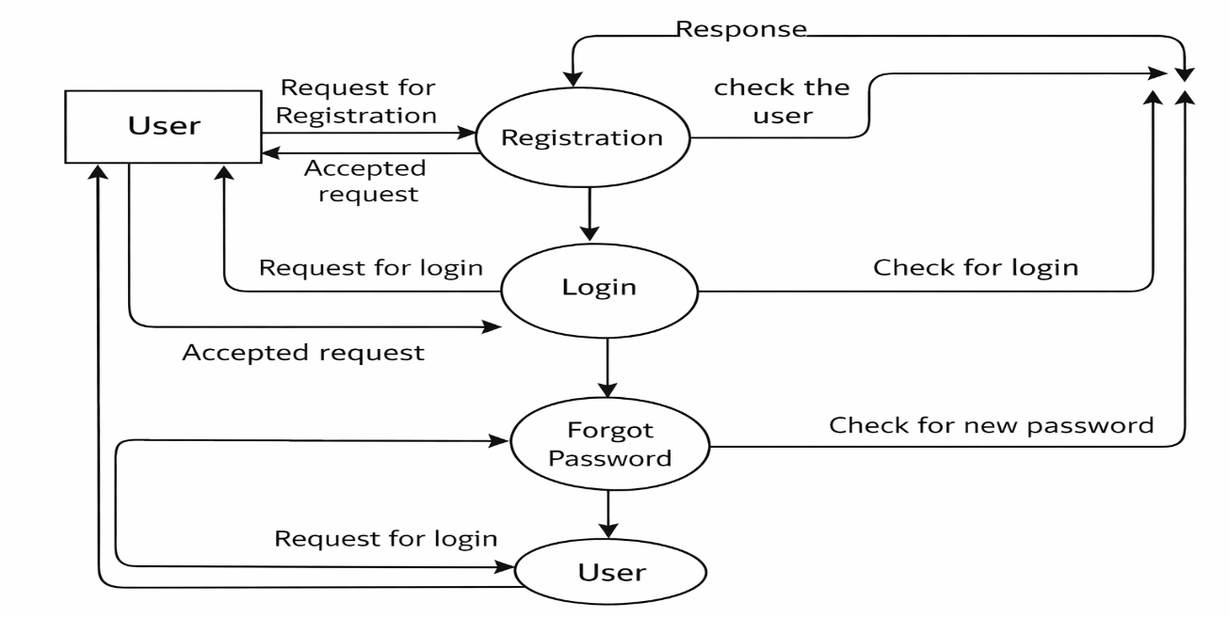
- 3. Reservation Management
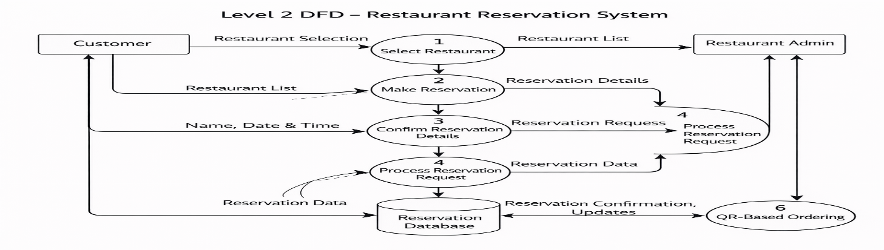
  - 4. Order Management
